Name Muddassir Ali

Registration SP21-BSE-016

Lab Task Fully dressed use case diagram.

**1 sign up**

**2 signin**

**3 View feed back**

**4 view timetables**

**Sign up**

|  |  |
| --- | --- |
| Use Case Name | Sign up |
| Scope | Automatic attendance System face detection app |
| Level | Main function |
| Primary Actor | * Admin * Student * teacher |
| Stake holders and interests | * Admin * Student * teacher |
| Preconditions | User must have to visit the website or app and proper internet |
| Success guarantee | Users (Student, teacher, admin) enter your own registration and password and retype password will be same so account has been created and store in data base. |
| Main Success Scenario | Admin verify the email and verify code which is send by the user email.  Users click on register button account has been created. |
| Extensions | Your password is wrong or email |
| Special Requirements | 1: It should be reliable.  2: it has high performance and secure database.  3: User friendly: user can easily understand and handle in first use. |
| Technology and Data Variations List | Computer internet |
| Frequency of Occurrences | 24/7 |
| Miscellaneous | Admin cannot verify code user cannot register.  Email does not send to admin.  Internet issue.  Type and conform password do not match |

**sign in**

|  |  |
| --- | --- |
| Use Case Name | Login |
| Scope | Automatic attendance System face detection app |
| Level | Main function |
| Primary Actor | * Admin * Student * Teacher |
| Stake holders and interests | * Admin * Student * Teacher |
| Preconditions | User must have a valid account and enter a correct id and password. |
| Success guarantee | After the use case end and successful login and verification is complete. And interface will show in screen. |
| Main Success Scenario | System automatically verifies the username and password it is match in data base or not. |
| Extensions | Your password or email is wrong |
| Special Requirements | 1: It should be reliable.  2: it has high performance and secure database.  3: User friendly: user can easily understand and handle in first use. |
| Technology and Data Variations List | Computer Internet |
| Frequency of Occurrences | 24/7 |
| Miscellaneous | User (student, admin, teacher) enter a wrong email and password and they does not excess the website. |

**View feed back**

|  |  |
| --- | --- |
| Use Case Name | View feedback |
| Scope | Automatic attendance System face detection app |
| Level | Main function |
| Primary Actor | Teacher  parents |
| Stake holders and interests | parents  Teacher |
| Preconditions | After the successful mark attendance teacher can generate feedback those who not present |
| Success guarantee | Parent can know about their children report. |
| Main Success Scenario | When the student is absent, the feedback of their absentees will be generated to their parents. |
| Extensions |  |
| Special Requirements | It should be safe and reliable  Good performance speed. |
| Technology and Data Variations List | Through login we will see feedbacks |
| Frequency of Occurrences | 24/7 |
| Miscellaneous | User (student, admin, teacher) enter a wrong email and password and they does not excess the website. |

**4 : View Timetable**

|  |  |
| --- | --- |
| Use Case Name | View timetable |
| Scope | Automatic attendance System face detection app |
| Level | Main function |
| Primary Actor | Teacher  Student |
| Stake holders and interests | Student (Wants to view timetable to know about time and room number of his/her class.)  Teacher (Wants to view timetable to about the class whom he/she will teach and the time of class). |
| Preconditions | Each must be logged in to their account. |
| Success guarantee | Timetable is shown to teacher or student. |
| Main Success Scenario | Teacher requests log in to the system  System processes the request and allow access to teacher.  Teacher searches the timetable  Timetable is shown on its screen. |
| Extensions | No internet |
| Special Requirements | It should be safe and reliable  Good performance speed. |
| Technology and Data Variations List | Through login we will see feedbacks |
| Frequency of Occurrences | Depend upon changing the timetable. |
| Miscellaneous | If rooms are not available.  If time is not set timetable clash. |

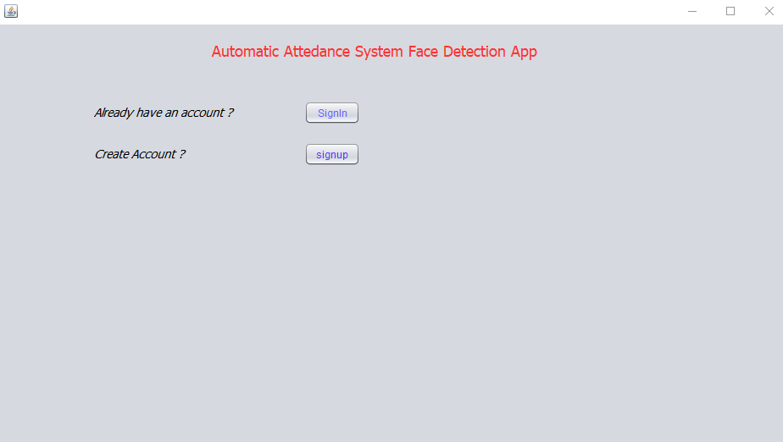

When you click on sign in button

When you click on sign in button so this interface will show

